**FACE RECOGNITION BASED ATTENDANCE SYSTEM**

**A Project report submitted in partial fulfillment of the requirements for the award of the**

**degree of**

MASTERS’S

**IN**

COMPUTER APPLICATION

**Submitted by**

SUBHASISH KARMAKAR (233451024)

NAYAN KANPILE (233451022)

PRADNYA PAWAR (233451036)

**Under the guidance of**

**DR. MEHER**





**CONTENTS**

|  |  |  |
| --- | --- | --- |
| **ABSTRACT** | | |
| **LIST OF FIGURES** | | |
| **LIST OF TABLES** | | |
| **CHAPTER 1 INTRODUCTION** | | |
| 1.1 | Project Objective | |
| 1.2 | Background | |
| 1.3 | Problem Statement | |
| 1.4 | Aims and Objectivee | |
| 1.5 Flow chart | | |
| 1.6 | Scope of the project | |
| **CHAPTER 2 LITERATURE REVIEW** | | |
| 2.1 | | Student Attendance System |
| 2.2 | | Digital Image Processing |
| 2.3 | | Image Representation in a Digital Computer |
| **CHAPTER 3 MODAL IMPLEMENTATION AND ANALYSIS** | | |
| 3.1 | | Introduction |
| 3.2 | | Modal Implementation |
| 3.3 | | Design Requirements |

|  |  |
| --- | --- |
| **CHAPTER 4 CODE IMPLEMENTATION** | |
| 4.1 | Code Implementation |
|  | 4.1.1 main.py |
|  | 4.1.2 automail py |
|  | 4.1.3 capture_image,py |
|  | 4.1.4 checkcamera.py |
|  | 4.1.5 Train_image.py |
|  | 4.1.6 Recognize.py |
|  | 4.1.7 requirement.txt |
| 4.2 | Sample Images |
| **CHAPTER 5 WORKPLAN** | |
| 5.1 | Introduction |
| 5.2 | Work Breakdown Structure |
|  | 5.2.1 Work plan |
|  | 5.2.2 Financial Plan |
| **CHAPTER 6 PERFORMANCE ANALYSIS** | |
| 6.1 | Introduction |
| 6.2 | Analysis |
|  |  |

**ABSTRACT**

In colleges, universities, organizations, schools, and offices, taking attendance is one of the most important tasks that must be done on a daily basis. The majority of the time, it is done manually, such as by calling by name or by roll number. The main goal of this project is to create a Face Recognition-based attendance system that will turn this manual process into an automated one. This project meets the requirements for bringing modernization to the way attendance is handled, as well as the criteria for time management. This device is installed in the classroom, where and student's information, such as name, roll number, class, sec, and photographs, is trained. The images are extracted using Open CV. Before the start of the corresponding class, the student can approach the machine, which will begin taking pictures and comparing them to the qualified dataset. Logitech C270 web camera and NVIDIA Jetson Nano Developer kit were used in this project as the camera and processing board. The image is processed as follows: first, faces are identified using a Haarcascade classifier, then faces are recognized using the LBPH (Local Binary Pattern Histogram) Algorithm, histogram data is checked against an established dataset, and the device automatically labels attendance. An Excel sheet is developed, and it is updated every hour with the information from the respective class instructor.

**Keywords**: Face Detection, Face Recognition, HaarCascade classifier, NVIDIA Jetson Nano

**CHAPTER-1**

**INTRODUCTION**

**Project Objective:**

Attendance is prime important for both the teacher and student of an educational organization. So it is very important to keep record of the attendance. The problem arises when we think about the traditional process of taking attendance in class room.

Calling name or roll number of the student for attendance is not only a problem of time consumption but also it needs energy. So an automatic attendance system can solve all above problems.

There are some automatic attendances making system which are currently used by much institution. One of such system is biometric technique and RFID system. Although it is automatic and a step ahead of traditional method it fails to meet the time constraint. The student has to wait in queue for giving attendance, which is time taking.

This project introduces an involuntary attendance marking system, devoid of any kind of interference with the normal teaching procedure. The system can be also implemented during exam sessions or in other teaching activities where attendance is highly essential. This system eliminates classical student identification such as calling name of the student, or checking respective identification cards of the student, which can not only interfere with the ongoing teaching process, but also can be stressful for students during examination sessions. In addition, the students have to register in the database to be recognized. The enrolment can be done on the spot through the user-friendly interface.

**Problem Statement:**

Traditional student attendance marking technique is often facing a lot of trouble. The face recognition student attendance system emphasizes its simplicity by eliminating classical student attendance marking technique such as

4

calling student names or checking respective identification cards. There are not only disturbing the teaching process but also causes distraction for students during exam sessions. Apart from calling names, attendance sheet is passed around the classroom during the lecture sessions. The lecture class especially the class with a large number of students might find it difficult to have the attendance sheet being passed around the class. Thus, face recognition attendance system is proposed in order to replace the manual signing of the presence of students which are burdensome and causes students get distracted in order to sign for their attendance. Furthermore, the face recognition based automated student attendance system able to overcome the problem of fraudulent approach and lecturers does not have to count the number of students several times to ensure the presence of the students.

The paper proposed by Zhao, W et al. (2003) has listed the difficulties of facial identification. One of the difficulties of facial identification is the identification between known and unknown images. In addition, paper proposed by Pooja G.R et al. (2010) found out that the training process for face recognition student attendance system is slow and time-consuming. In addition, the paper proposed by Priyanka Wagh et al. (2015) mentioned that different lighting and head poses are often the problems that could degrade the performance of face recognition based student attendance system.

Hence, there is a need to develop a real time operating student attendance system which means the identification process must be done within defined time constraints to prevent omission. The extracted features from facial images which represent the identity of the students have to be consistent towards a change in background, illumination, pose and expression. High accuracy and fast computation time will be

**Aims and Objectives:**

The objective of this project is to develop face recognition attendance system.

Expected achievements in order to fulfill the objectives are:

* To detect the face segment from the video frame.
* To extract the useful features from the face detected.
* To classify the features in order to recognize the face detected.
* To record the attendance of the identified student.

**Scope of the project:**

We are setting up to design a system comprising of two modules. The first module (face detector) is a mobile component, which is basically a camera application that captures student faces and stores them in a file using computer vision face detection algorithms and face extraction techniques. The second module is a desktop application that does face recognition of the captured images (faces) in the file, marks the students register and then stores the results in a database for future analysis.

1.5 **Flow chart**

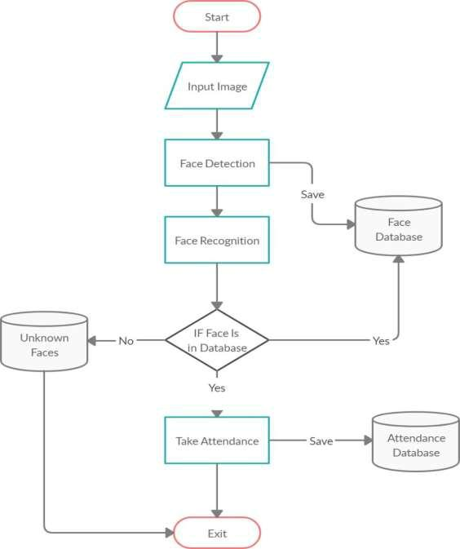

**CHAPTER-2**

**LITERATURE REVIEW**

**Student Attendance System:**

Arun Katara et al. (2017) mentioned disadvantages of RFID (Radio Frequency Identification) card system, fingerprint system and iris recognition system. RFID card system is implemented due to its simplicity. However, the user tends to help their friends to check in as long as they have their friend’s ID card. The fingerprint system is indeed effective but not efficient because it takes time for the verification process so the user has to line up and perform the verification one by one. However for face recognition, the human face is always exposed and contain less information compared to iris. Iris recognition system which contains more detail might invade the privacy of the user. Voice recognition is available, but it is less accurate compared to other methods. Hence, face recognition system is suggested to be implemented in the student attendance system.

|  |  |  |  |
| --- | --- | --- | --- |
| **System Type** | **Advantage** | **Disadvantages** |  |
|  |  |  |  |
| RFID card system | Simple | Fraudulent usage |  |
|  |  |  |  |
| Fingerprint system | Accurate | Time-consuming |  |
|  |  |  |  |
| Voice recognition system |  | Less accurate compared |  |
|  |  | to Others |  |
| Iris recognition system | Accurate | Privacy Invasion |  |
|  |  |
|  |  |  |  |

**Face Recognition**

Face Recognition is a visual pattern recognition problem, where the face, represented as a three dimensional object that is subject to varying illumination

12

Viola-Jones algorithm which was introduced by P. Viola, M. J. Jones (2001) is the most popular algorithm to localize the face segment from static images or video frame. Basically the concept of Viola-Jones algorithm consists of four parts. The first part is known as Haar feature, second part is where integral image is created, followed by implementation of Adaboost on the third part and lastly cascading process.

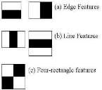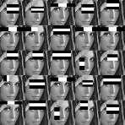

Viola-Jones algorithm analyses a given image using Haar features consisting of multiple rectangles (Mekha Joseph et al., 2016).

In the fig shows several types of Haar features. The features perform as window function mapping onto the image. A single value result, which representing each feature can be computed by subtracting the sum of the white rectangle(s) from the sum of the black rectangle(s).

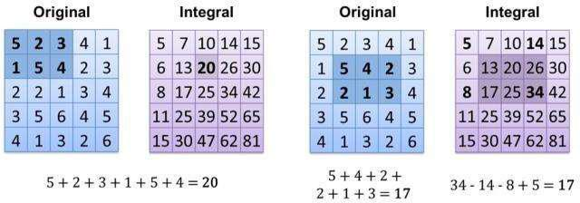

he value of integrating image in a specific location is the sum of pixels on the left and the top of the respective location. In order to illustrate clearly, the value of the integral image at location 1 is the sum of the pixels in rectangle A. The values

15

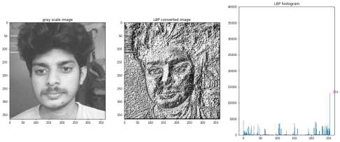

1. **Extracting the Histograms:** Now, using the image generated in the last step, we can use the Grid X and Grid Y parameters to divide the image into multiple grids, as can be seen in the following image:

**CHAPTER-3**

**MODAL IMPLEMENTATION**

**AND ANALYSIS**

ace detection involves separating image windows into two classes; one containing faces (turning the background (clutter). It is difficult because although commonalities exist between faces, they can vary considerably in terms of age, skin color and facial expression. The problem is further complicated by differing lighting conditions, image qualities and geometries, as well as the possibility of partial occlusion and disguise. An ideal face detector would therefore be able to detect the presence of any face under any set of lighting conditions, upon any background. The face detection task can be broken down into two steps. The first step is a classification task that takes some arbitrary image as input and outputs a binary value of yes or no, indicating whether there are any faces present in the image. The second step is the face localization task that aims to take an image as input and output the location of any face or faces within that image as some bounding box with (x, y, width, height).After taking the picture the system will compare the equality of the pictures in its database and give the most related result.

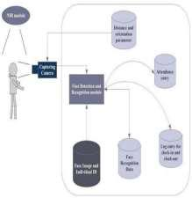

The main components used in the implementation approach are open source computer vision library (OpenCV). One of OpenCV’s goals is to provide a simple-to-use computer vision infrastructure that helps people build fairly sophisticated vision applications quickly. OpenCV library contains over 500 functions that span many areas in vision. The primary technology behind Face recognition is OpenCV. The user stands in front of the camera keeping a minimum distance of 50cm and his image is taken as an input. The frontal face is extracted from the image then converted to gray scale and stored.

**Design Requirements:**

We used some tools to build the system. Without the help of these tools it would not be possible to make it done. Here we will discuss about the most important one.

**Software Implementation:**

1. **OpenCV:** We used OpenCV 3 dependency for python 3. OpenCV is library where there are lots of image processing functions are available. This is very useful library for image processing. Even one can get expected outcome without writing a single code. The library is cross-platform and free for use under the open-source BSD license. Example of some supported functions are given bellow:
   * **Derivation**: Gradient/Laplacian computing, contours delimitation
   * **Hough transforms:** lines, segments, circles, and geometrical shapes detection

23

* **Histograms**: computing, equalization, and object localization with back projection algorithm
* **Segmentation**: thresholding, distance transform, foreground/background detection, watershed segmentation
* **Filtering**: linear and nonlinear filters, morphological operations
* **Cascade detectors**: detection of face, eye, car plates
* **Interest points**: detection and matching
* **Video processing:** optical flow, background subtraction, camshaft (object tracking)
* **Photography**: panoramas realization, high definition imaging (HDR), image inpainting

**CHAPTER-4**

**CODE IMPLEMENTATION**

**Code Implementation:**

All our code is written in Python language. First here is our project directory structure and files.

FRASJN

|  |  |  |  |  |  |
| --- | --- | --- | --- | --- | --- |
| | |  | [Attendance] | | | |
|  |  |  |  |  |  | |
| | |  | [ImagesUnknown] | | | |
|  |  |  | |  |  | |
| | |  | [StudentDetails] | | | |
|  |  |  |  | |  | |
| | |  | [TrainingImage] | | | |
|  |  |  |  | |  | |
| | |  | [Traininglabel] | | | |
|  |  |  |  | |  | |
| | |  | main.py | | | |
| | |  | automail.py | | | |
| | |  | CaptureImage.py | | | |
| | |  | check_camera.py | | | |
| | |  | haarcascade_frontalface_default.xml | | | |
| | |  |  |  |  | recognize.py | |
| | |  |  |  |  | requirements.txt | |

All those file in the project directory.

Note: The names inside square brackets [“folder name”] indicate it is a folder.

[Attendance] => It contains all the attendance sheets saved after taking attendance.

[ImagesUnknown] => Unknown images are placed inside this folder to avoid false positives.

[StudentDetails] => Here we place Studentdetails.csv file to use while recognizing faces.

[Trainingimage] => After capture dataset of a student, all his/her images are stored here.

**4.1.1 main.py**

All the work will be done here, Detect the face ,recognize the faces and take attendance.

**CHAPTER-5**

**WORK PLAN**

**Introduction:**

A project work plan allows you to outline the requirements of a project, project

planning steps, goals, and team members involved in the project.Within each goal, you're going to outline the necessary Key Action Steps in project planning, the requirements, and who's involved in each action step.

**Key Action Step:**

* Expected Outcome -Add this as a task. The Expected outcome will be the part of Project
* Assignees – Assigning the work to the team members.
* Completion Date -Add a due date and tries to finish the work within the time

**5.2 Work Breakdown Structure:**

In order to develop this system, we gave enormous importance to scheduling because we believed if we want to provide the best of quality in a given period of time then we must give due importance to scheduling which also helped us to achieve a better results.we observe the entire work structure, meaning how the scheduling was maintained throughout the developmental phase. We shall also see the financial foundation of this project and furthermore the feasibility study should be also discussed.

|  |  |  |
| --- | --- | --- |
|  | **Activity** | **status** |
| **Month** |  |  |
| SEPTEMBER | Selection of project area and Study of the | Completed |
|  | related work. |  |
|  | (NAYAN , PRADNYA & SUBHASISH ) |  |
| OCTOBER | Literature Survey and Study of Journals | Completed |
|  | related to the work |  |
|  | (NAYAN & PRADNYA) |  |
| NOVEMBER | Study on the software implementation | Completed |
|  | works python and image processing |  |
|  | (NAYAN , PRADNYA & SUBHASISH ) |  |
|  |  |  |

**CHAPTER-6**

**PERFORMANCE ANALYSIS**

**Introduction:**

We conducted a series of experiments to illustrate the system performance under different situations. By carrying out those tests, we were able to get the graph shown above (Distance vs Confidence Level). We may deduce from the graph that when the face is closer to the camera, the confidence level is higher, and vice versa. Therefore, by keeping a threshold for confidence level, we can mark attendance to the person according to the threshold.